What It Is
A simple stock system written in C# using Visual Studio 2026 and SSRS for reporting.

Has transaction recording for:
- Stock Issues
- Location renaming
- Lot deletion
- Location deletion!

Uses SQL Server backend.

Technical Issues and Information
This system didn’t incur any real challenges, the only real issue was not going to far and start laying down the foundations for a fully fledged ERP system!
Where possible as many activities/system events as possible where focused into centralised functions. The system has separate internal structures:
- Screens, such as Stock Item Maintenance.
- Reports, such as UOM Listing.
- Modules, consists of: clsData used for database and validation, clsView used for GUI manipulation, form reset, opening forms etc.
Additional:
This document is in on-going development, so expect changes!

Installing:
This test version requires a SQL Server installation, and SSRS installed. If you are looking at the code make sure your using Visual Studio 2026.
In Solution Explorer -> Manage NuGet Packages:
Add:
Microsoft.ReportingServices.ReportViewerControl.Winforms
Microsoft.Data.SQLClient
Microsoft.SQLServer.Types

Rather clumsily I forgot to change the PC’s name so embarrassingly it is called: DESKTOP-694Q8HR
Best way obviously to test this application is via a virtual machine, either way create a folder in drive C called: C:\RogStock2026
GitHub links for latest versions:
Rogstock 2026
https://github.com/TheRog-007/RogStock2026.git
Rogstock 2026 - utilities
https://github.com/TheRog-007/RogStock2026_Utilities.git

From the application folder (RogStock2026) copy the following folders into C:\RogStock2026:
Reports
Resources

Compile the EXE and copy from:
\RogStock2026Suite\RogStock2026\RogStock2026\bin\Debug
Into:
C:\RogStock2026

SQL Server was primitively configured i.e. no special user for database access, uses SQL authentication and the user details used are:
Name: sa
Password: RogSQLServer1
If this was written as a commercial system then clearly this method would be unacceptable!
The datasource in the reports uses the PC name so make sure they match!

The projects full path is:
C:\projects\VisualStudio\Csharp\RogStock2026
This folder contains sub folders for the projects:
- RogStock2026
- RogStock_Utilities
- RogStock2026_Reports_Edit – creating/editing SSRS reports
- RogStock2026_Reports_Test – for testing the report filter screens
- There is the latest BAK file for SQL Server in the SQLServerDatabase folder in: RogStock2026

This system has one admin user, whose credentials are:
Name: admin
Password: password

The Screens:
The login screen is where you access the system:
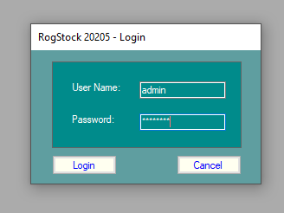
The login screen does these functions:
- Validates user name and password.
- Creates a login record in: Login_Current which contains the user ID, date/time logged in and the PCs IP address.

When logged in the main menu screen appears:
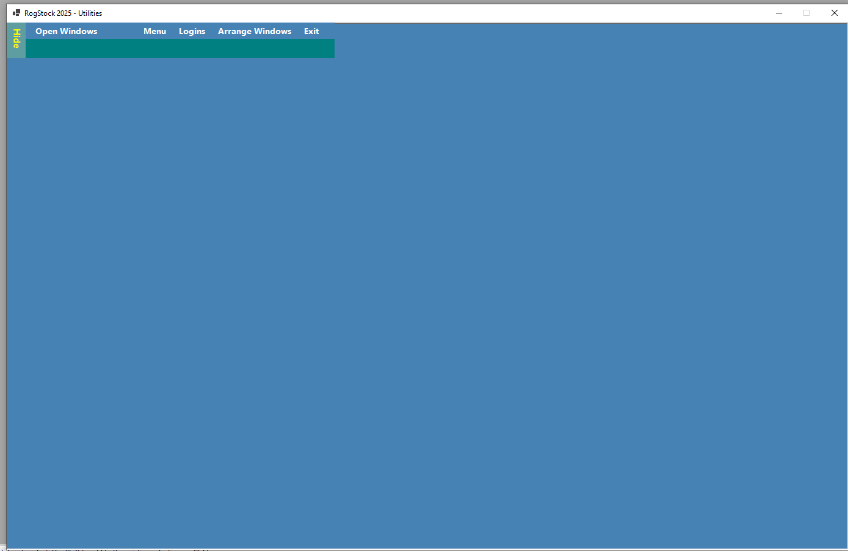
Click on the button on the top left of the screen to display options
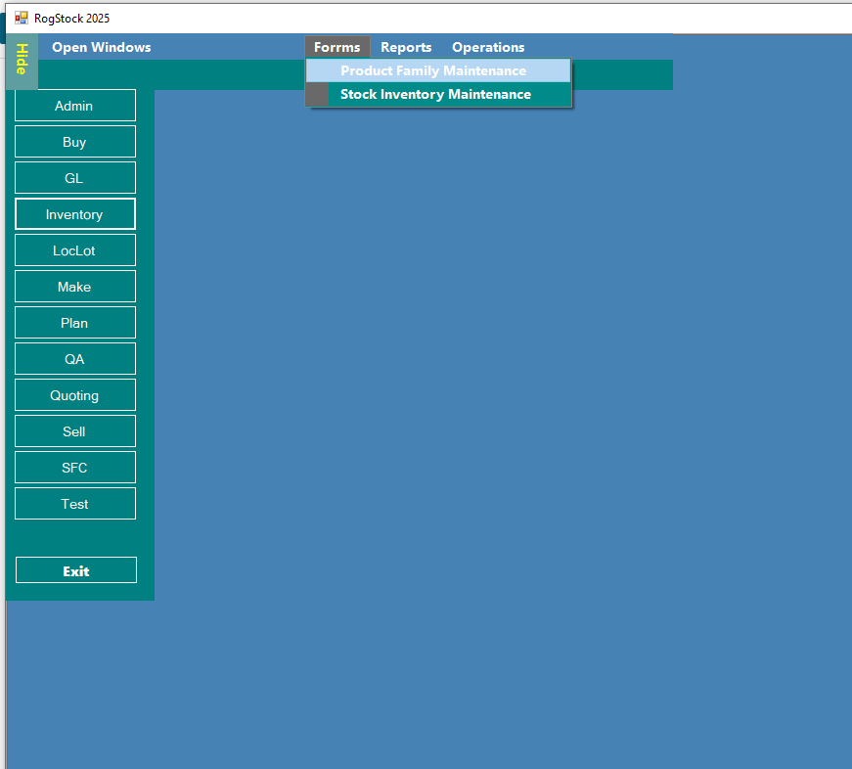
Selecting one of these populates the above menu options depending on user access rights

Let’s look at each screen the system offers!

Stock Items Maintenance:
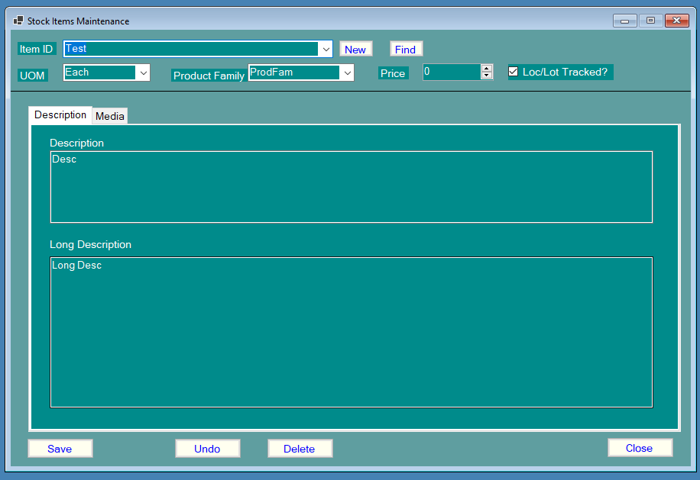
Use this screen to create/maintain stock items.
As with every screen in the system required data is always highlighted red.
What some of the screen items are for:
- Loc/Lot tracked sets the system to ensure for every location for the item there is one lot. If the item is Loc/Lot tracked and you uncheck it the system will want you that on save it will delete all associated lot records!
- Description has two options a mandatory short description (512 characters max) and an optional long description (4096 characters max).
- Media this allows one or more files to be associated with the stock item, selected one and the system saves the path to the file rather than saving the actual item as this make housekeeping easier and avoids massive SQL database sizes. The system supports a fixed range of types these are: PDF, JPEG, PNG, GIF.

A selected media file can (sometimes) be viewed in the viewer by simply double clicking the item:
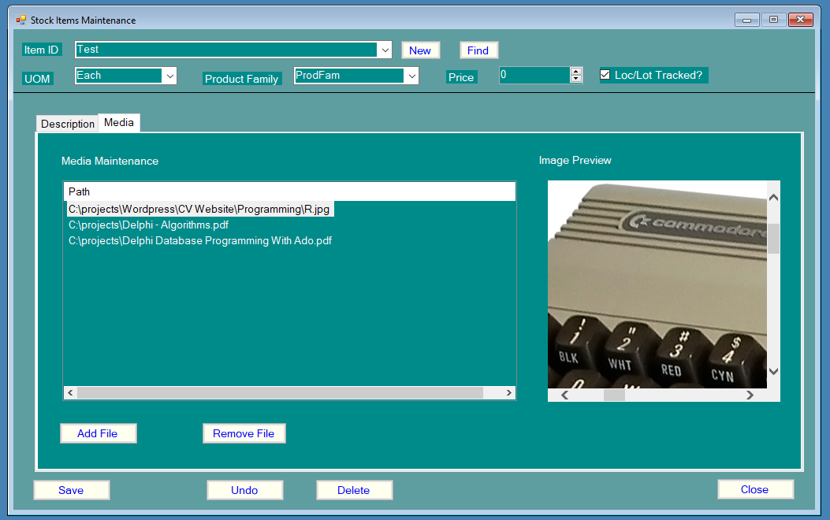

Note: Before this screen can be used make sure you created at least UOM and product family record else the screen will tell you it can’t open!
Descriptions are stored in: Stock_Descriptions.
Media data is stored in Stock_Media.

Stock Location Maintenance:
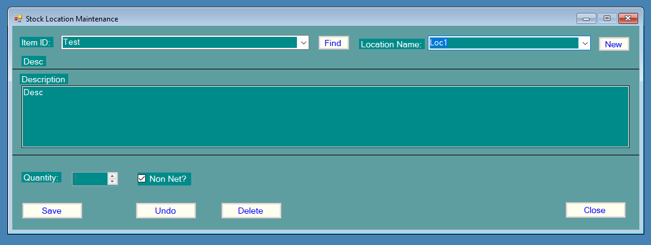
Each item can be in multiple locations, this screen maintains/creates that information. The Non Net options exists but in this version does nothing!
After an item is created in the previous screen, this is the next screen to use. Here you create the location for the item and its quantity.
If the item is Loc/Lot tracked when saved will automatically create a lot for the item. This can also be achieved somewhat unconventially via the Adjust Quantity screen.

Note: If the item is Loc/Lot tracked when deleted will also delete all associated lots, also creates a
transaction record.
Also if Loc/Lot tracked adjustment of location quantity is disabled, use Adjust Quantity screen
for that operation.

Stock Lot Maintenance:
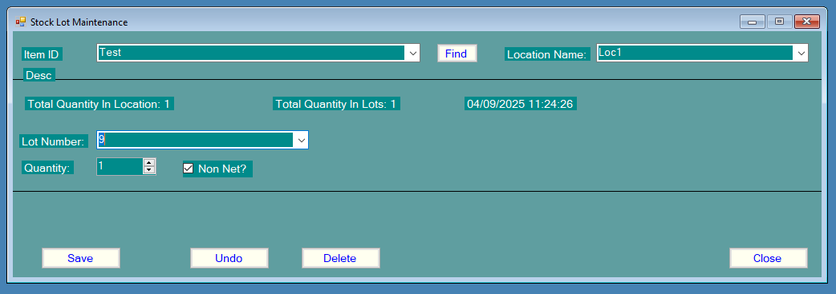
This screen allows maintenance of existing lots, and are automatically created when Loc/Lot tracking is turned on in the Stock Items Maintenance screen.
This screen also writes transactions for each save.
Lots can only deleted if:
- Not the only lot for the item and location.
- Deleting the lot does not means the total quantity in lots is lower than the parent location quantity.
The Non Net options exists but in this version does nothing!
Note: Lot quantity adjustments must match the parent locations quantity, the system will not save data that will cause a stock imbalance.

Stock Product Family Maintenance:
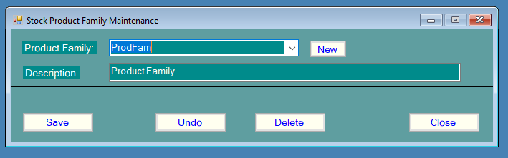
This screen maintains product family information. Product family and UOM records need to exist before the Stock Items Maintenance screen can be used.
Note: A product family can only be deleted if it not in referenced by a stock item. If it is use Product Family Mass Replace to change it in existing stock items.

Adjust Quantity:
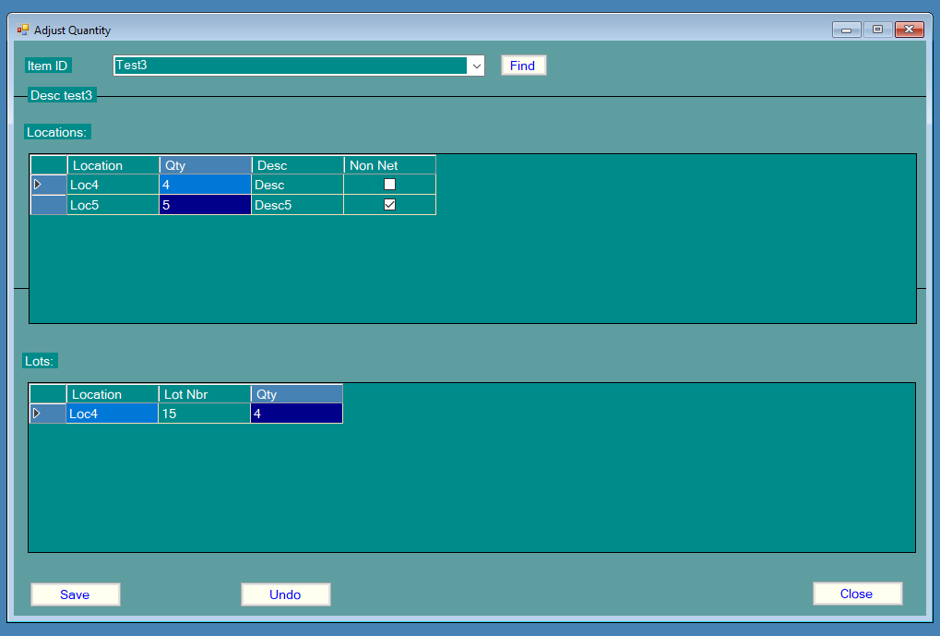
This screen is used to adjust location/lot values.
Double click the location quantity box for the selectde location to edit, same applies to the lot quantity.
If the item is Loc/Lot tracked but has no lots, when you double click the location quantity a message will appear informing you of this. At this point you can click “Save” and create the lot or adjust the location quantity first, when saved will automatically create a lot for the item.
Note: if an items is Loc/Lot tracked the total lot quantities must equal the parent location quantitiy else the screen will refuse to save the data and create a stock inbalance! Creates Loc/Lot transaction records.

Use Stock:
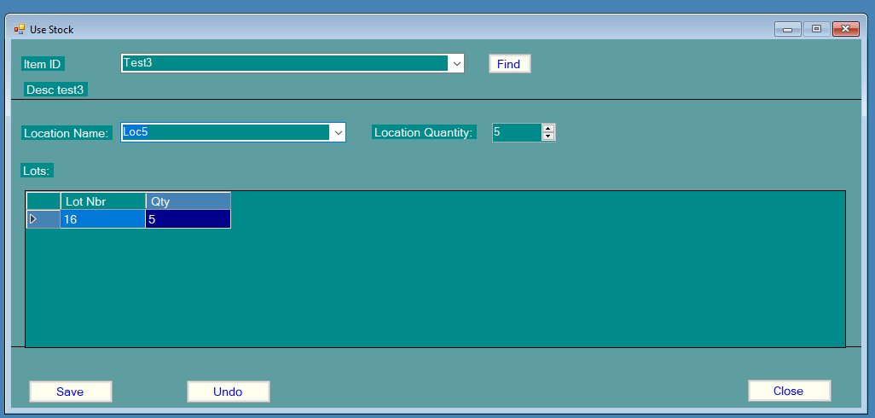
Use this screen to consume (issue) stock quantities.
Note: This screen will not allow changes to be saved if lot quantities do not match the parent location quantity. Creates Loc/Lot transaction records.

Rename Location:
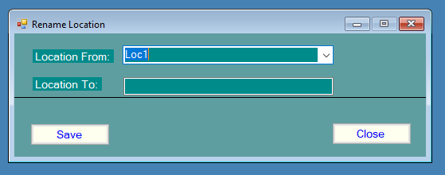
This screen allows locations to be renamed.

Stock Unit Of Measure Maintenance:
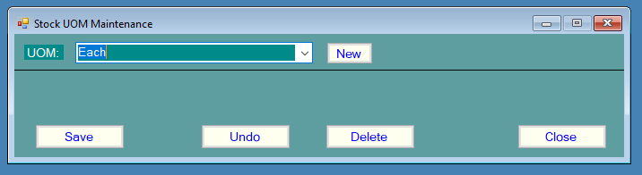
This screen maintains UOM types.
Note: As with product family maintenance screen if referenced by stock item cannot delete, use UOM Mass Replace to modify affected stock items before delete.
Product Family Mass Replace:
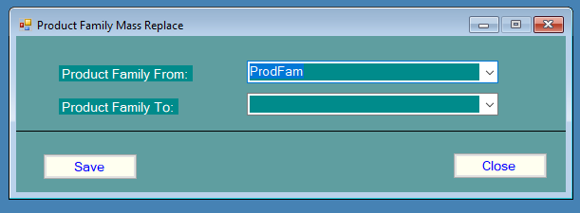
User this screen to replace one product family with another, used mainly if need to delete one as first needs to be removed from referenced stock items.
UOM Mass Replace:
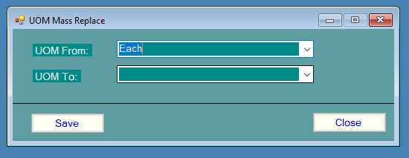
This screen is used to replace one UOM used in stock items with another, used before deleting a UOM.
Next is reports!
Find:
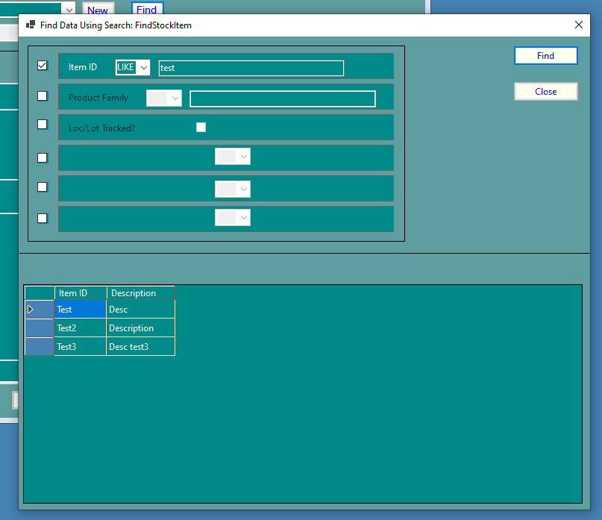
Available filter options
Compare your custom value with standard operators: < > <> =
Also use LIKE to search for similar values
Some screens have a “Find” button click this to search for items in more detail by using comparison operators and filters.
E.g.: As in this example show all stock items with item ID similar to “test”.

The Reports:
Stock Item Listing:
This is available in two flavours:
- Basic
- All information
What this means is “All information” also includes detail of any media files associated with the item.
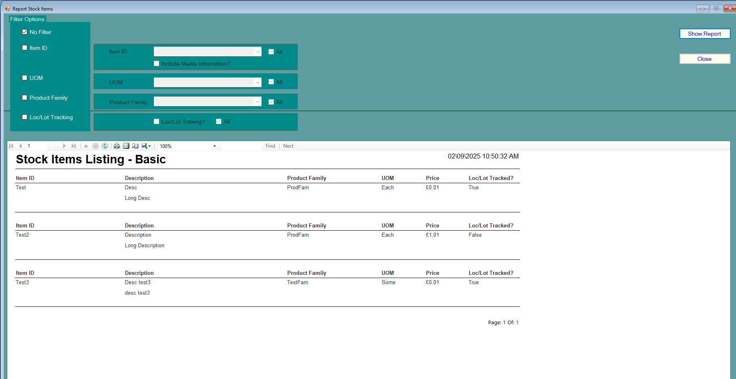

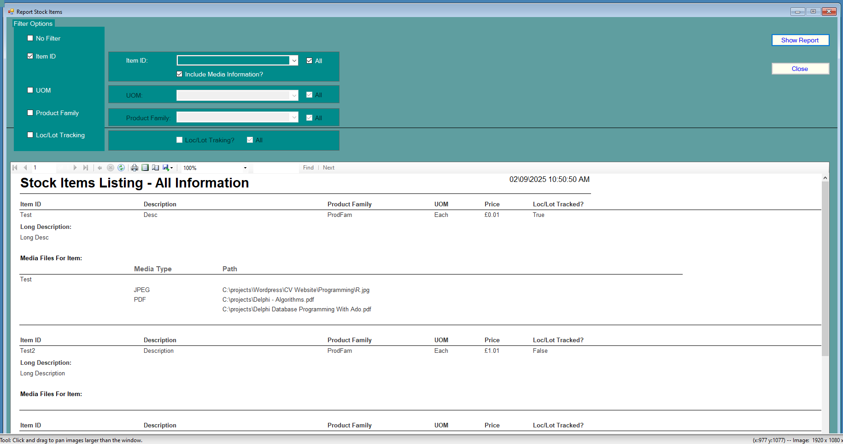
This report allows all sorts of data to sort for regarding stock items via the comprehensive filter section. Reports can be printed or exported to PDF etc!
Stock – UOM Listing:
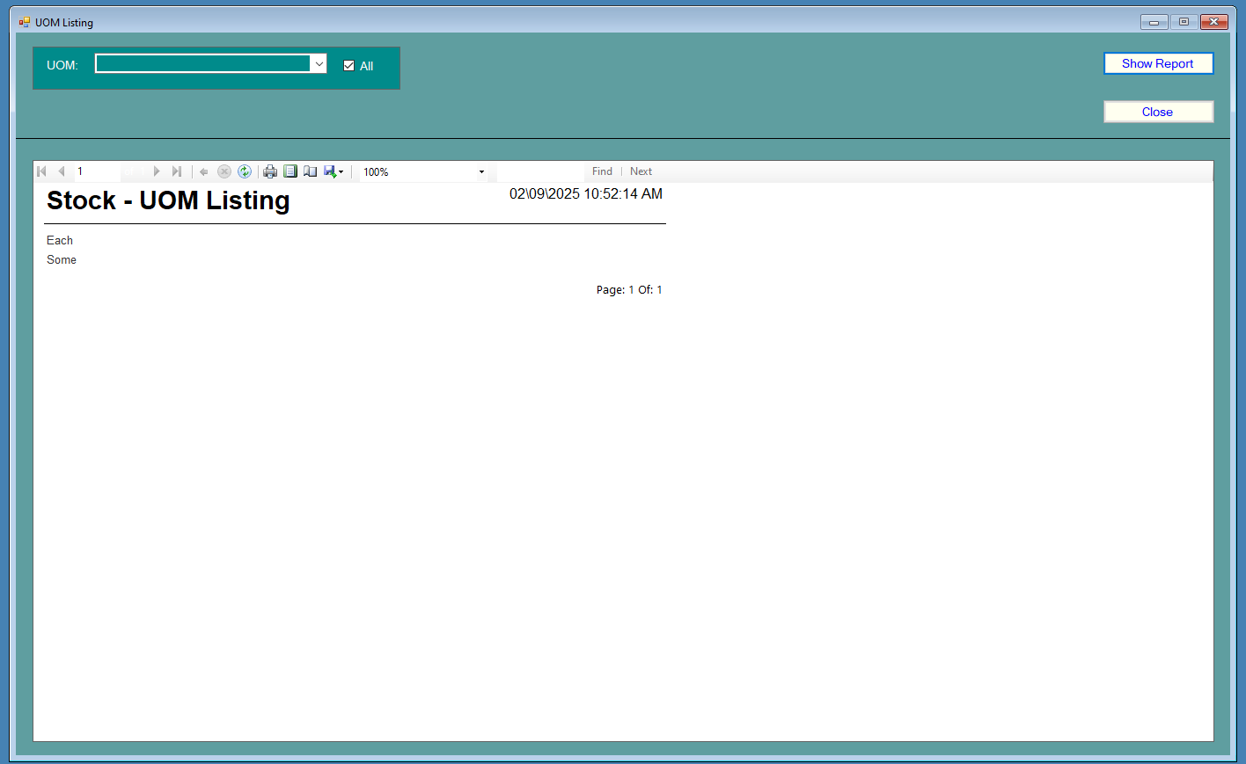
Shows UOM data in the system.
Note: UOM records are stored in: Stock_UOM.
Stock Product Family listing:
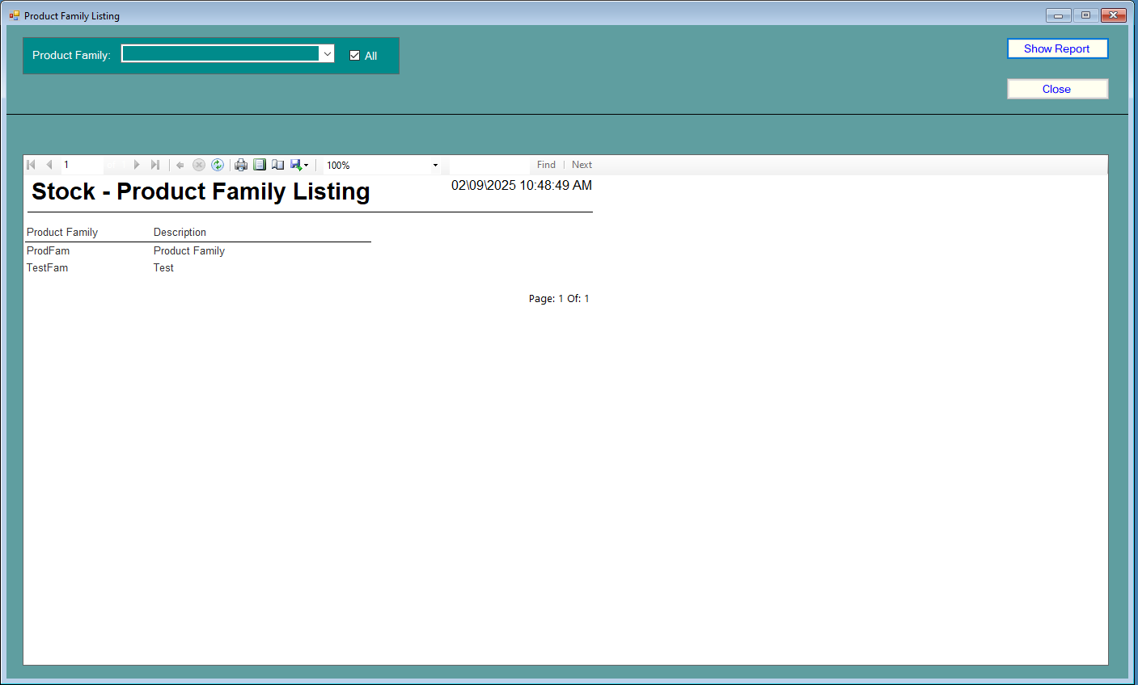
Shows product family data in the system.
Note: Records are stored in: Stock_ProductFamily.
Location Listing:
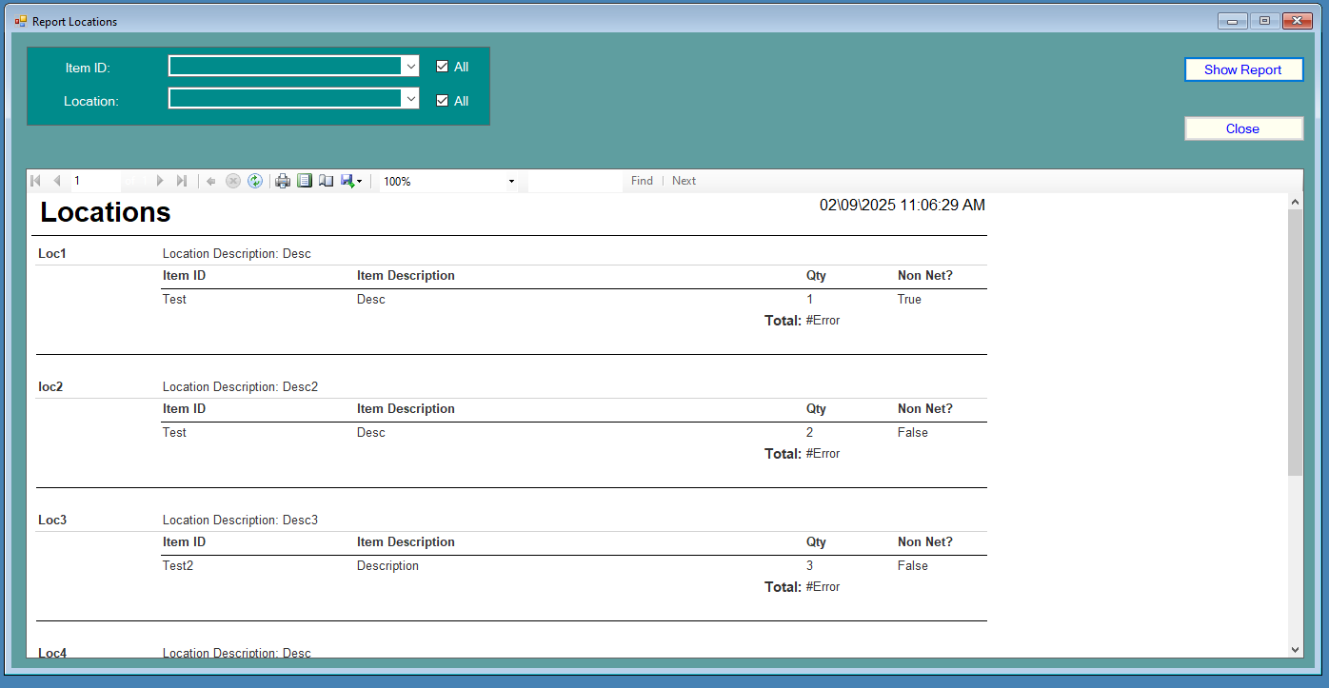
Shows location data in the system.
Note: Location data stored in: Stock_Loc.
Lots Listing:
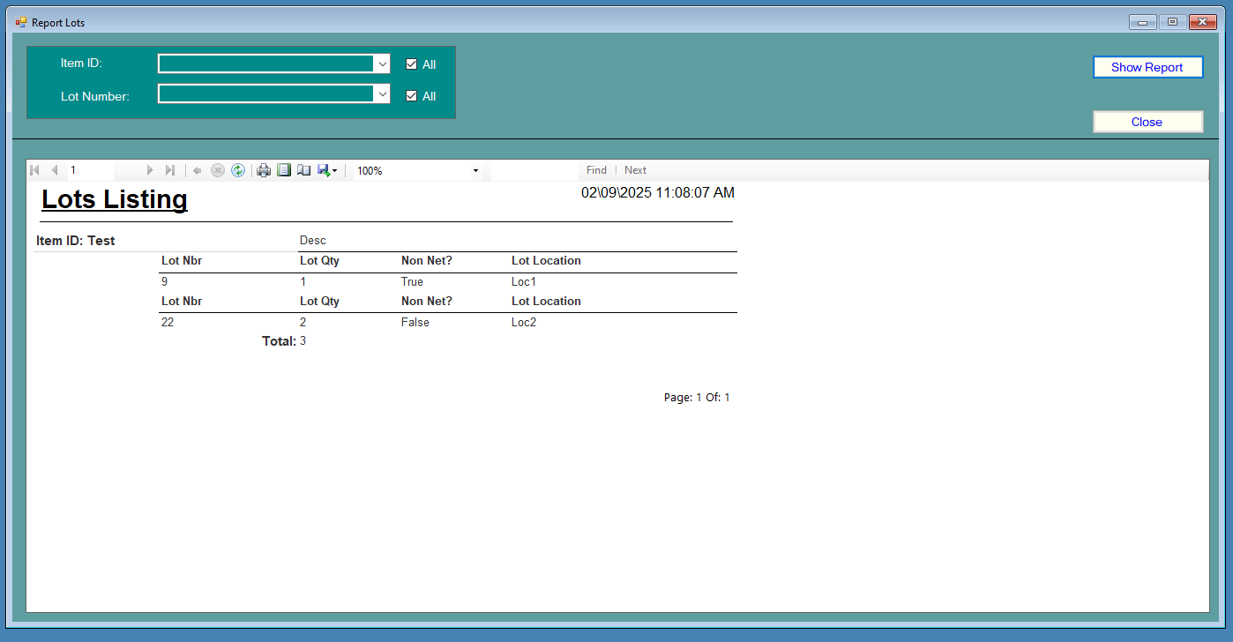
Shows location data in the system.
Note: Location data stored in: Stock_Lot.

Location Transactions:
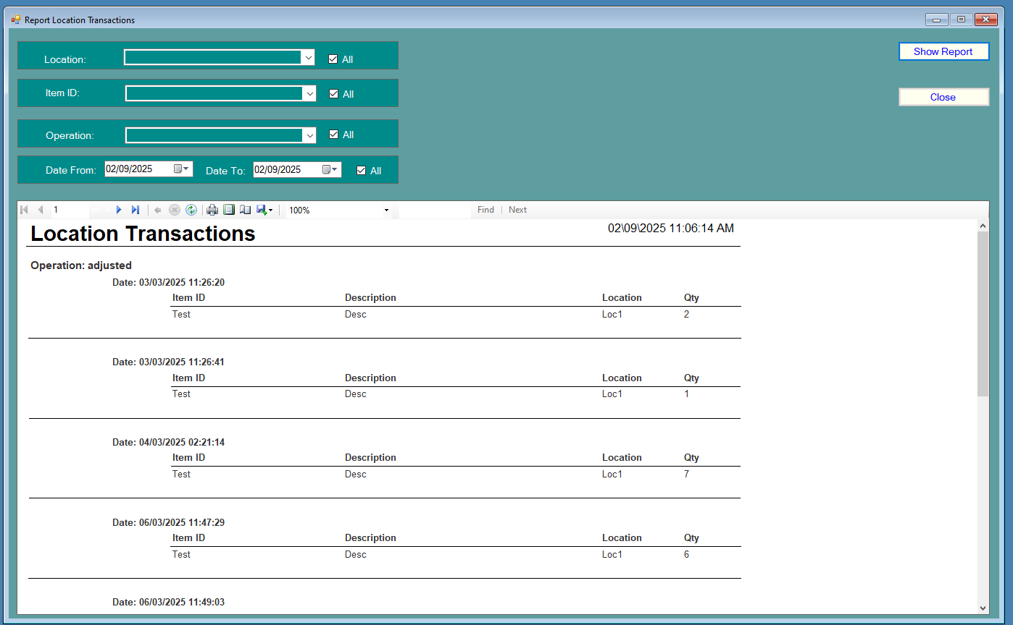
Shows all transactions for location via filter criteria or show all records.
Lot Transactions:
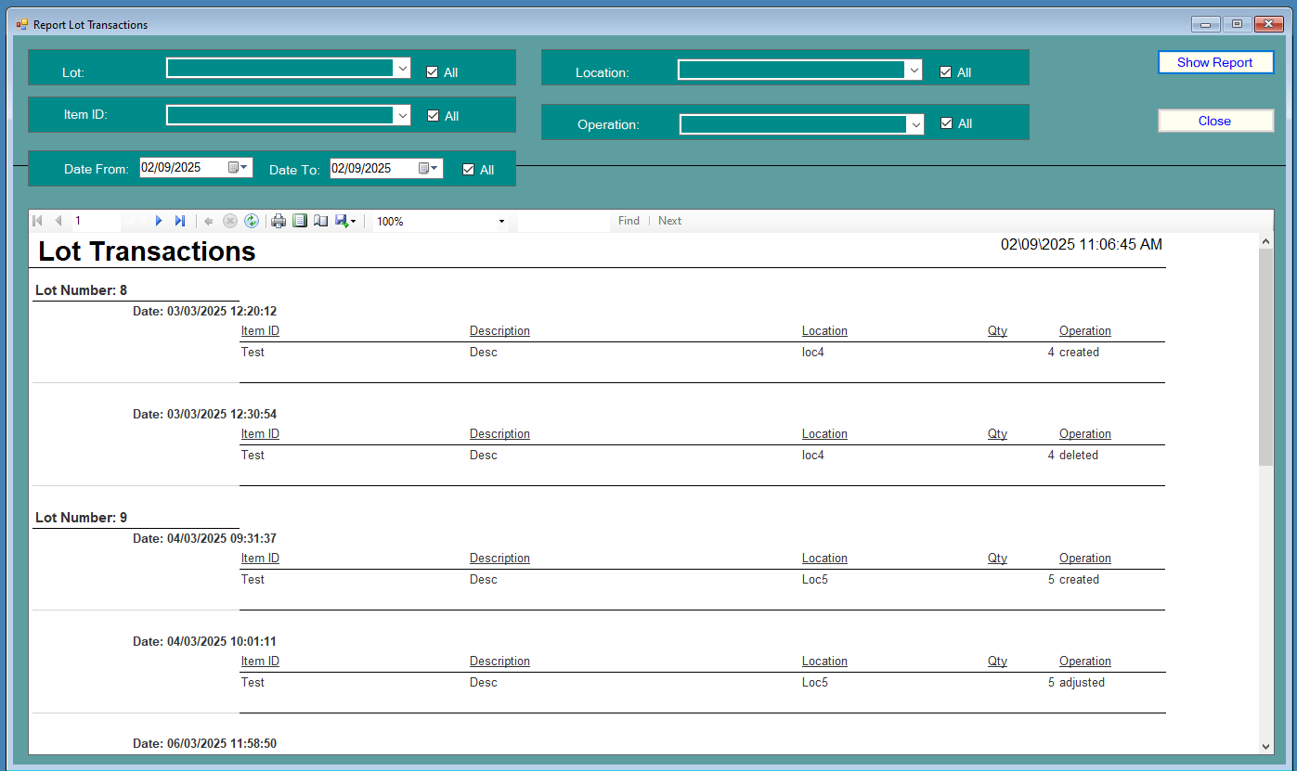
Shows all transactions for lot via filter criteria or show all records.

Stock Item Transactions:
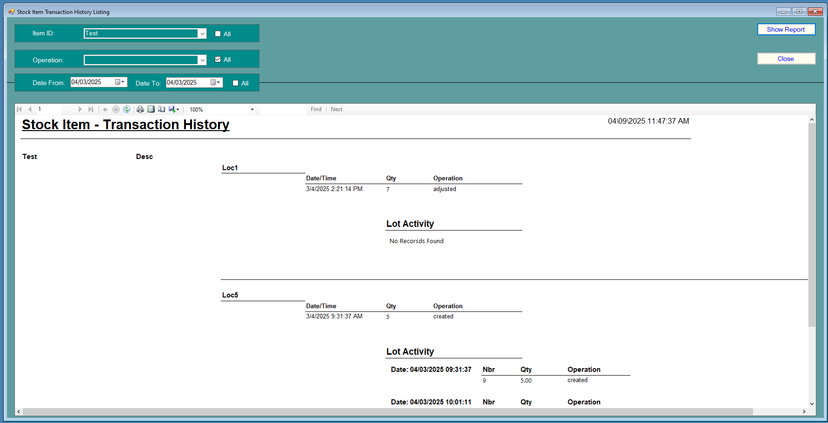
This drills down to lots if any exist.
Note: will show all lot transaction for item unless a date range is specified.
Logins:
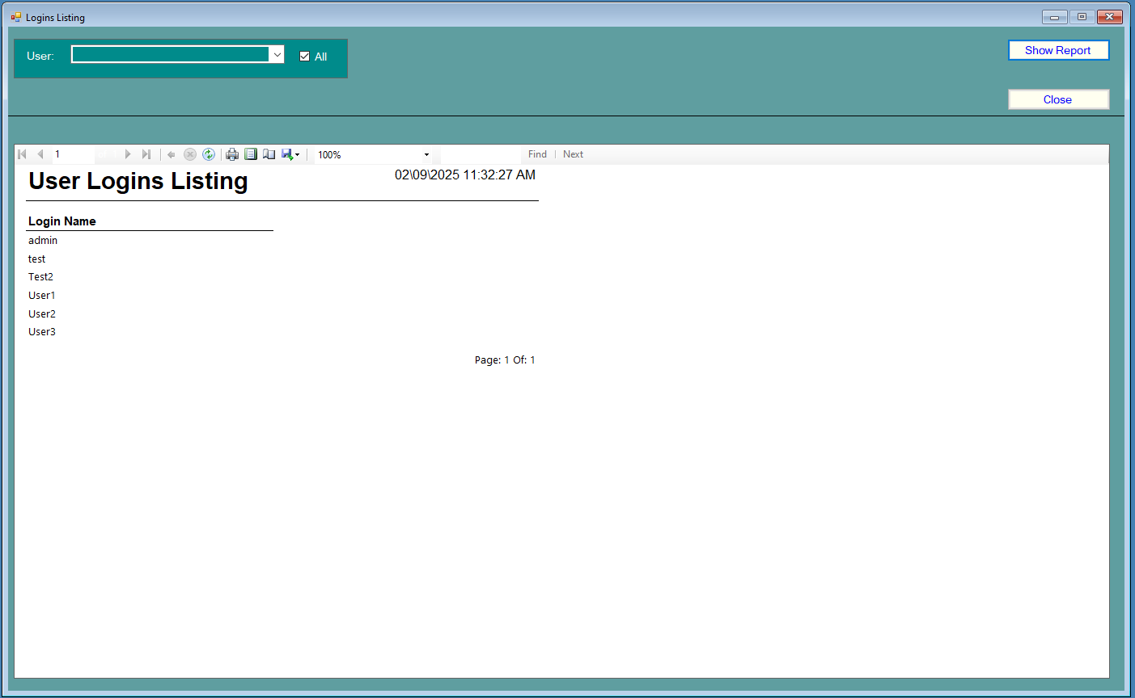
Shows a list of system users.

Current Logins:
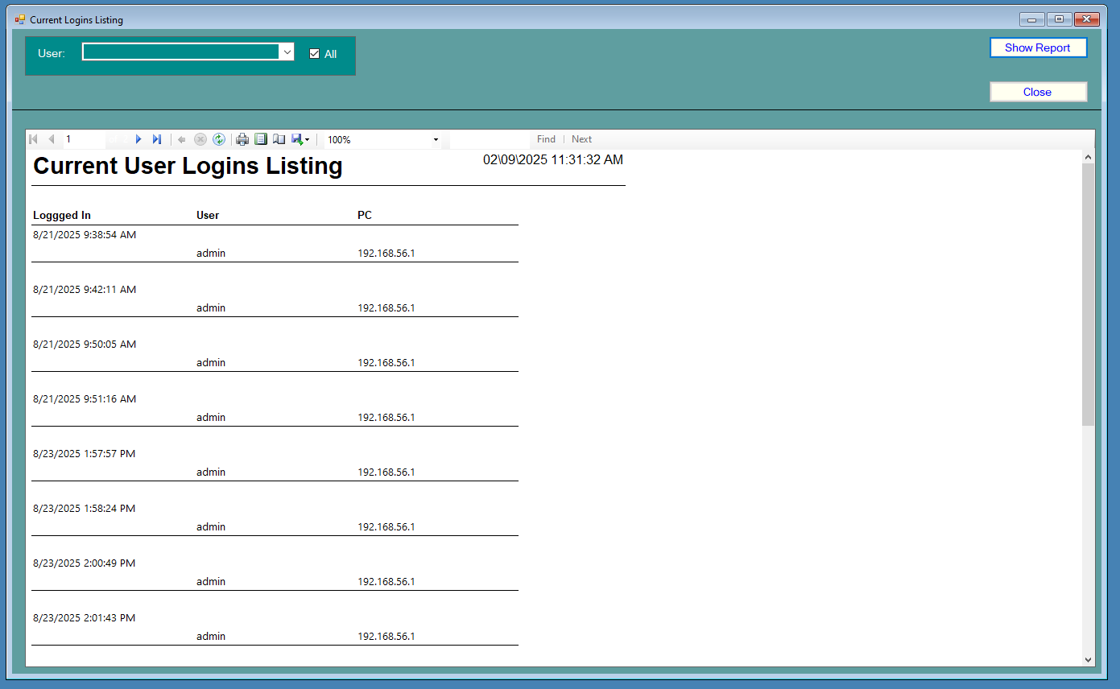
Shows list of users currently logged in and their PC IP address.

User Groups:
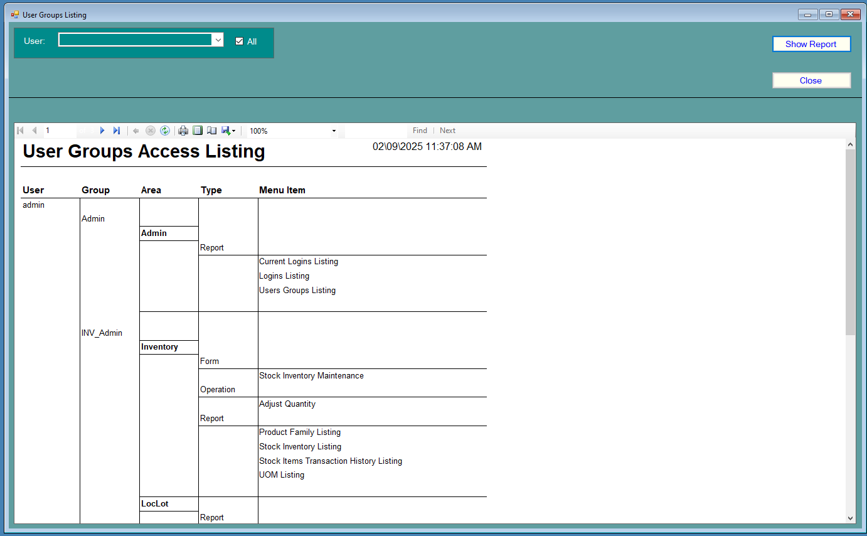
This shows the access right the user has based on the security groups they are part of.

RogStock2026 - Utilities
This is the backbone of the system. This is where the fundamental elements of the system e.g. menu areas, items and users are created.
First here are the screens:
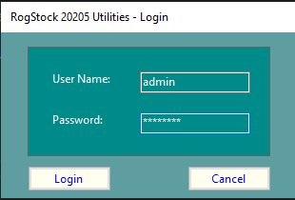
Similar to main system
Note: When the application is finished only admin users will have access!

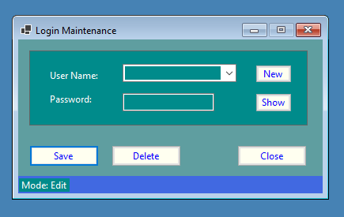
This is where users are maintained, note the handy “Show” button should a user forget their password!

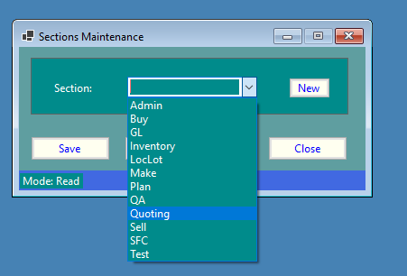
Sections Maintenance.
This is used to create/delete system sections, each section can have its own reports/screens and users and without sections there is no main menu!
Later in this document is explained the interconnectivity of sections and the system architecture.
Note: Be VERY careful, deleting existing sections in this development version as it is irreversible.
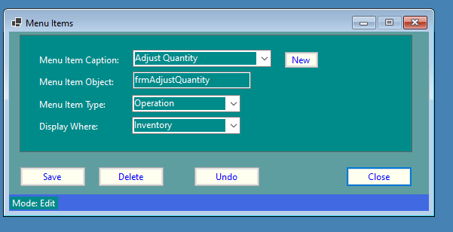
Menu Items Maintenance.
Here the items displayed in the menus are maintained.
Note: Deleting one will also remove any associated groups and user groups (see later).
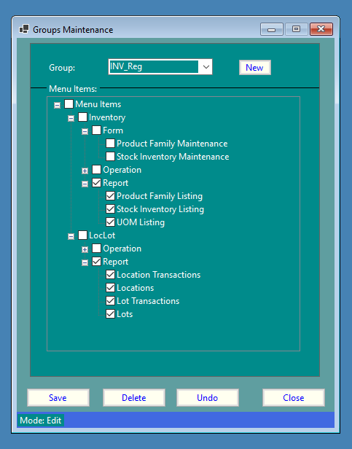
Group maintenance.
Here menu items are associated with groups, many groups can associate with the same menu item
Note: Deleting one will also remove any associated user groups (see later).

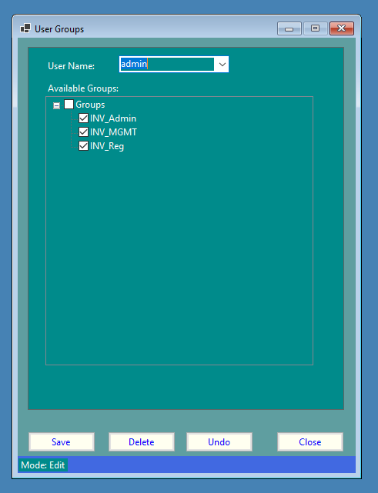
User group maintenance.
Here users are associated with security groups, each user can be a member of more than one group.

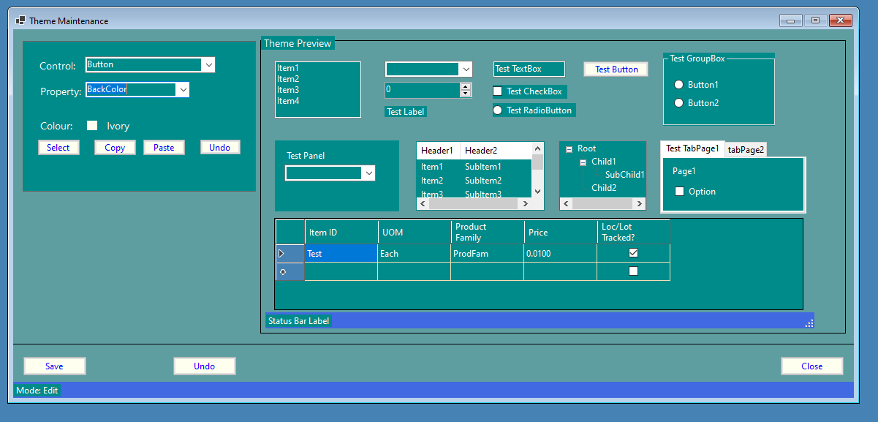
Theme Maintenance.
This modifies colours for:
- RogStock
- RogStock – Utilities
This allows customisation of the global colour scheme. This right hand screen is a preview of the changed colours, clicking the “Select” button shows the colour selection screen:
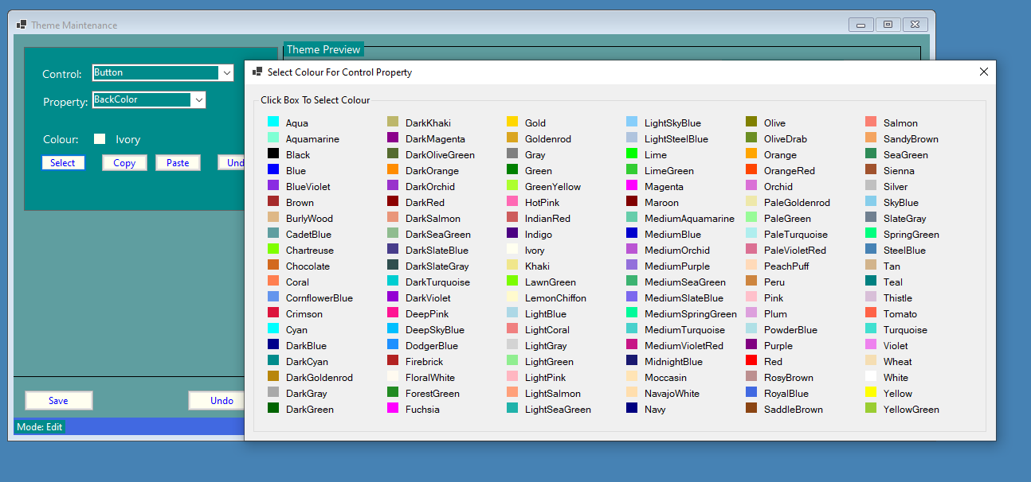
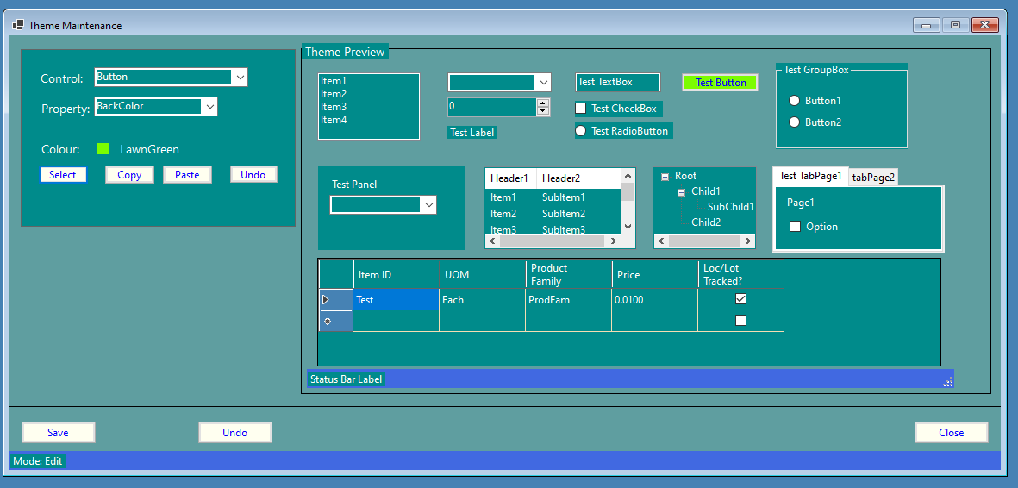
Once selected the changes is shown in the preview section of the screen.

Note: Saved scheme is stored in the Resources sub folder of the application.
Also in this development version selected datagrid cell is hardcoded to dark blue, as there is no defined selected cell back colour property, thinking caps on for that solution!

Menu System Tables Hierarchy

Logins
User Groups
Menu Items
Groups
Sections

RogStock 2026 – Tables
Table: Login
Field Name | Description | Type | Size | Primary Key?
LOG_ID | Autonumber | int |  | Y
LOG_User | User name | varchar | 30 | N
LOG_Password | Password | varchar | 10 | N
LOG_ClockNbr | Clock Number | int |  | N

Table: Login_Current
Field Name | Description | Type | Size | Primary Key?
LOGC_ID | Autonumber | int |  | Y
LOGC_User | User name | varchar | 30 | N
LOGC_DateTime | When logged in | date | 10 | N
LOGC_PCIP | IP address of PC | varchar | 20 | N

Table: Stock_Loc
Field Name | Description | Type | Size | Primary Key?
LOC_ID | Autonumber | int |  | Y
LOC_ItemID | Name | varchar | 50 | N
LOC_Qty | Quantity | int |  | N
LOC_Location | Location | varchar | 30 | N
LOC_Updated | Date/Time updated | datetime |  | N
LOC_NonNet | Non Net? | boolean |  | N
LOC_Description | Description | varchar | 30 | N

Table: Stock_Lot
Field Name | Description | Type | Size | Primary Key?
LOT_ID | Autonumber | int |  | Y
LOT_ItemID | Name | varchar | 50 | N
LOT_Nbr | Lot Number | int |  | N
LOT_Qty | Quantity | int |  | N
LOT_NonNet | Non Net? | boolean |  | N
LOT_Updated | Date/Time updated | datetime |  | N
LOT_Location | Location | varchar | 30 | N

Table: Stock_Items
Field Name | Description | Type | Size | Primary Key?
STKI_ID | Autonumber | int |  | Y
STKI_ItemID | Name | varchar | 50 | N
STKI_UOM | Unit of Measure | varchar | 20 | N
STKI_ProductFamily | Product Family | varchar | 20 | N
STKI_Price | Price | money |  | N
STKI_LocLot | Loc/Lot Tracking? | Boolean |  | N

Table: Stock_Vendors
Field Name | Description | Type | Size | Primary Key?
STKV_ID | Autonumber | int |  | Y
STKV_ItemID | Name | varchar | 50 | N
STKV_VendorID | Vendor | int |  | N
STKV_Price | Price | money |  | N
STKV_Preferred | Preferred Vendor? | boolean |  | N

Table: Stock_Description
Field Name | Description | Type | Size | Primary Key?
STKD_ID | Autonumber | int |  | Y
STKD_Desc | Description | varchar | 512 | N
STKD_LongDesc | Long Description | text |  | N
STKD_ItemID | Item ID | varchar | 50 | N

Table: Stock_Media
Field Name | Description | Type | Size | Primary Key?
STKM_ID | Autonumber | int |  | Y
STKM_ItemID | Item ID | varchar | 50 | N
STKM_Path | Path | varchar | 100 | N
STKM_Type | PDF/Image etc | varchar | 10 | N

Table: Loc_TRN
Field Name | Description | Type | Size | Primary Key?
LOCT_ID | Autonumber | int |  | Y
LOCT_ItemID | Name | varchar | 50 | N
LOCT_Location | Location | varchar | 30 | N
LOCT_OldLocation | Previous Name | varchar | 30 | N
LOCT_Qty | Quantity | int |  | N
LOCT_DateTime | Date/Time | datetime |  | N
LOCT_Operation | Operation | varchar | 30 | N

Table: Lot_TRN
Field Name | Description | Type | Size | Primary Key?
LOTT_ID | Autonumber | int |  | Y
LOTT_Nbr | Lot Number | int |  | N
LOTT_ItemID | Name | varchar | 50 | N
LOTT_Qty | Quantity | int |  | N
LOTT_DateTime | Date/Time | datetime |  | N
LOTT_Location | Location | varchar | 30 | N
LOTT_Operation | Operation | varchar | 30 | N

Table: Stock_ProductFamily
Field Name | Description | Type | Size | Primary Key?
SKTP_ID | Autonumber | int |  | Y
SKTP_ProductFamily | Product Family | varchar | 30 | N
SKTP_Desc | Description | varchar | 30 | N

Table: Stock_UOM
Field Name | Description | Type | Size | Primary Key?
STKU_ID | Autonumber | int |  | Y
STKU_Desc | Description | varchar | 20 | N

Table: Find_FieldInfo
Field Name | Description | Type | Size | Primary Key?
FFI_ID | Autonumber | int |  | Y
FFI_SearchType | Search Type | varchar | 50 | N
FFI_Tablename | Table Name | varchar | 50 | N
FFI_Fieldname | Field Name | varchar | 50 | N
FFI_Order | Sort Order | int |  | N
FFI_FieldDataType | Data Type | varchar | 10 | N
FFI_LabelText | Text For User | varchar | 50 | N
FFI_FieldLength | Field Length | int |  | N
FFI_DecimalPlaces | Decimal Places | int |  | N

Table: Find_Relations
Field Name | Description | Type | Size | Primary Key?
FFR_ID | Autonumber | int |  | Y
FFR_SearchType | Search Type | varchar | 50 | N
FFR_Tablename | Table Name | varchar | 50 | N
FFR_QualifiedJoin | SQL Join | varchar | 512 | N
FFR_SearchCondition | Search Condition | varchar | 50 | N
FFR_IsDefault | Default | boolean |  | N
FFR_OtherTableFields | Other Table Fields | varchar | 255 | N
FFR_Distinct | Distinct Search | boolean |  | N
FFR_GroupBy | Group By | varchar | 50 | N
FFR_OrderBy | Order By | varchar | 50 | N
Table: Menu_Areas
Field Name | Description | Type | Size | Primary Key?
SEC_ID | Autonumber | int |  | Y
SEC_Area | Menu Section | varchar | 20 | N

Table: Menu_Groups
Field Name | Description | Type | Size | Primary Key?
GRP_ID | Autonumber | int |  | Y
GRP_Group | Security Group | varchar | 20 | N
GRP_MenuItem | Menu Item | varchar | 50 | N

Table: Menu_MenuItems
Field Name | Description | Type | Size | Primary Key?
MNU_ID | Autonumber | int |  | Y
MNU_MenuItemName | Menu Item | varchar | 50 | N
MNU_MenuItemObject | Form Name | varchar | 50 | N
MNU_Type | Form/Report etc | varchar | 10 | N
MNU_DisplayWhere | Area To Show | varchar | 50 | N

Table: Menu_UsersGroups
Field Name | Description | Type | Size | Primary Key?
USRGRP_ID | Autonumber | int |  | Y
USRGRP_User | User | varchar | 20 | N
USRGRP_Group | Group | varchar | 20 | N

Table: Purchase Orders
Field Name | Description | Type | Size | Primary Key?
POM_ID | Autonumber | Int |  | Y
POM_VendorID | Vendor ID | Int |  | N
POM_OrderDate | Order Date | Date |  | N
POM_Buyer | Buyer | Varchar | 30 | N
POM_OrderType | Order Type | Varchar | 15 | N
POM_SpecialInst | Special Instructions | Varchar | 512 | N
POM_PrintedDate | Date Printed | Datetime |  | N
POM_Printed | PO Printed? | Bit |  | N
POM_RequisitionNbr | Requisition Nbr | Int |  | N
POM_APTermsDesc | AP Terms Desc | Varchar | 30 | N
POM_Region | Region | Varchar | 50 | N
POM_ShipMethod | Ship Method | Varchar | 30 | N
POM_VBA | Billing Address ID | Int |  | N

Table: Purchase Orders - Lines
Field Name | Description | Type | Size | Primary Key?
POL_ID | Autonumber | Int |  | Y
POL_POLineNbr | Line Nbr | Int |  | N
POL_LineType | Line Type | Varchar | 15 | N
POL_UOM | UOM | Varchar | 20 | N
POL_ItemID | Item ID | Varchar | 50 | N
POL_Desc | Item Description | Varchar | 512 | N
POL_Reference | Reference | Varchar | 50 | N
POL_DeliverTo | Deliver To ID | Int |  | N
POL_Inspect | Inspect? | Bit |  | N
POL_StatusCode | Status Code | Varchar | 10 | N
POL_PurConvUOM | PO UOM | Varchar | 10 | N
POL_SpecialInst | Special Instructions | Varchar | 512 | N
POL_PurConvFactor | PO UOM Factor | Float |  | N
POL_Taxable | Taxable? | Bit |  | N
POL_EmployeeID | Created By | varchar | 30 | N

Table: Purchase Orders - Deliveries
Field Name | Description | Type | Size | Primary Key?
POM_ID | Autonumber | Int |  | Y
POM_VendorID | Vendor ID | Int |  | N
POM_OrderDate | Order Date | Date |  | N
POM_Buyer | Buyer | Varchar | 30 | N
POM_OrderType | Order Type | Varchar | 15 | N
POM_SpecialInst | Special Instructions | Varchar | 512 | N
POM_PrintedDate | Date Printed | Datetime |  | N
POM_Printed | PO Printed? | Bit |  | N
POM_RequisitionNbr | Requisition Nbr | Int |  | N
POM_APTermsDesc | AP Terms Desc | Varchar | 30 | N
POM_Region | Region | Varchar | 50 | N
POM_ShipMethod | Ship Method | Varchar | 30 | N
POM_VBA | Billing Address ID | Int |  | N

Table: Purchase Orders - Inspection
Field Name | Description | Type | Size | Primary Key?
POL_ID | Autonumber | Int |  | Y
POL_POLineNbr | Line Nbr | Int |  | N
POL_LineType | Line Type | Varchar | 15 | N
POL_UOM | UOM | Varchar | 20 | N
POL_ItemID | Item ID | Varchar | 50 | N
POL_Desc | Item Description | Varchar | 512 | N
POL_Reference | Reference | Varchar | 50 | N
POL_DeliverTo | Deliver To ID | Int |  | N
POL_Inspect | Inspect? | Bit |  | N
POL_StatusCode | Status Code | Varchar | 10 | N
POL_PurConvUOM | PO UOM | Varchar | 10 | N
POL_SpecialInst | Special Instructions | Varchar | 512 | N
POL_PurConvFactor | PO UOM Factor | Float |  | N
POL_Taxable | Taxable? | Bit |  | N
POL_EmployeeID | Created By | varchar | 30 | N

Table: Purchase Orders - Receipts
Field Name | Description | Type | Size | Primary Key?
POM_ID | Autonumber | Int |  | Y
POM_VendorID | Vendor ID | Int |  | N
POM_OrderDate | Order Date | Date |  | N
POM_Buyer | Buyer | Varchar | 30 | N
POM_OrderType | Order Type | Varchar | 15 | N
POM_SpecialInst | Special Instructions | Varchar | 512 | N
POM_PrintedDate | Date Printed | Datetime |  | N
POM_Printed | PO Printed? | Bit |  | N
POM_RequisitionNbr | Requisition Nbr | Int |  | N
POM_APTermsDesc | AP Terms Desc | Varchar | 30 | N
POM_Region | Region | Varchar | 50 | N
POM_ShipMethod | Ship Method | Varchar | 30 | N
POM_VBA | Billing Address ID | Int |  | N

Table: Purchase Orders - Lines
Field Name | Description | Type | Size | Primary Key?
POL_ID | Autonumber | Int |  | Y
POL_POLineNbr | Line Nbr | Int |  | N
POL_LineType | Line Type | Varchar | 15 | N
POL_UOM | UOM | Varchar | 20 | N
POL_ItemID | Item ID | Varchar | 50 | N
POL_Desc | Item Description | Varchar | 512 | N
POL_Reference | Reference | Varchar | 50 | N
POL_DeliverTo | Deliver To ID | Int |  | N
POL_Inspect | Inspect? | Bit |  | N
POL_StatusCode | Status Code | Varchar | 10 | N
POL_PurConvUOM | PO UOM | Varchar | 10 | N
POL_SpecialInst | Special Instructions | Varchar | 512 | N
POL_PurConvFactor | PO UOM Factor | Float |  | N
POL_Taxable | Taxable? | Bit |  | N
POL_EmployeeID | Created By | varchar | 30 | N

Stock Items Tables Hierarchy
Note: Keep this structure in mind when creating data in the system!
Lot
Transactions
Location Transactions
Lots
Locations
Stock Items
UOM
Product Families

System Design
The application folder design is thus:
C:\RogStock2026 - EXE file here
C:\RogStock2026\Reports – RDL/RDLC files here
C:\RogStock2026\Resources – theme file, custom SQL error messages file

The project folder design is thus:
Modules – class modules
Screens – forms
Resources – a copy of the one from the application folder
SQLServerDatabase – latest BAK of the SQL database
RogStock2026 User Manual Including Technical Information.pdf – this document your reading

System has three modules:
clsData - anything needed to access SQL data or query it etc as well as a host of constant variables
clsTable – anything to do with the SQL database schema including select queries
clsView – anything to do with the GUI from opening forms to selecting parent treeview nodes

A sort of database version of MVC!

Stored Procedures
-- =============================================
-- Author: Roger Williams
-- Create date: 07/07/2026
-- Description: Checks if passed user and password are valid
-- =============================================
CREATE PROCEDURE [dbo].[SP_CheckLogin]
-- Add the parameters for the stored procedure here
@User varchar(30), @Password varchar(10), @ErrorCustom int OUTPUT
AS
BEGIN
-- SET NOCOUNT ON added to prevent extra result sets from
-- interfering with SELECT statements.
SET NOCOUNT ON;

-- Insert statements for procedure here
-- Set @Result = SELECT LOG_User FROM Login WHERE LOG_User = @User;

SELECT LOG_User FROM Login WHERE LOG_User = @User AND LOG_Password = @Password

-- if not found return custom error number
if (@@ROWCOUNT = 0)
SET @ErrorCustom = 1000;
ELSE
SET @ErrorCustom = 0;
END

-- =============================================
-- Author: Roger Williams
-- Create date: 07/07/2026
-- Description: Checks if passed user has login record
-- =============================================
CREATE PROCEDURE [dbo].[SP_CheckLoginExists]
-- Add the parameters for the stored procedure here
@User varchar(30), @ErrorCustom int OUTPUT

AS
BEGIN
SET @ErrorCustom = 0;

-- SET NOCOUNT ON added to prevent extra result sets from
-- interfering with SELECT statements.
SET NOCOUNT ON;

SELECT LOG_User FROM Login WHERE LOG_User = @User;

-- no record? return custom error number
IF (@@ROWCOUNT) = 0
SET @ErrorCustom = 1001;

END

-- =============================================
-- Author: Roger Williams
-- Create date: 01/05/2026
-- Description: Creates new lot and stores identity
-- in LOT_Nbr and also returns it
--
-- Note: was using @@IDENTITY but switched to: IDENT_CURRENT('Stock_Lot')
-- to see how it differs!
-- =============================================
CREATE PROCEDURE [dbo].[sp_CreateNewLot]
@itemID varchar(50), @location varchar(30), @qty int, @lotNbr int OUTPUT, @ErrorCustom int OUTPUT
AS
BEGIN
SET @ErrorCustom = 0;

-- SET NOCOUNT ON added to prevent extra result sets from
-- interfering with SELECT statements.
SET NOCOUNT ON;

-- Insert statements for procedure here
INSERT INTO Stock_Lot (LOT_ItemID, LOT_Location, LOT_Qty) VALUES (@itemID, @location, @qty)
UPDATE Stock_Lot SET LOT_Nbr = IDENT_CURRENT('Stock_Lot') WHERE LOT_ItemID = @itemID AND LOT_Location = @location AND LOT_Qty = @qty;

-- if error use custom error for it
IF (@@ERROR) <> 0
SET @ErrorCustom =1003;
ELSE
SET @lotNbr = IDENT_CURRENT('Stock_Lot') -- return identity seed value
END

-- =============================================
-- Author: Roger Williams
-- Create date: 07/07/2026
-- Description: Returns password for user if user valid
-- =============================================
CREATE PROCEDURE [dbo].[SP_GetPassword]
-- Add the parameters for the stored procedure here
@User varchar(30), @Password varchar(10) OUTPUT, @ErrorCustom int OUTPUT
AS
BEGIN
SET @ErrorCustom = 0;

-- SET NOCOUNT ON added to prevent extra result sets from
-- interfering with SELECT statements.
SET NOCOUNT ON;

SELECT @Password = LOG_Password FROM Login WHERE LOG_User = @User

-- if not found return custom error
if (@@ROWCOUNT = 0)
SET @ErrorCustom = 1004;

END

